Annex A
BROUGHSHANE 5K ROUTE

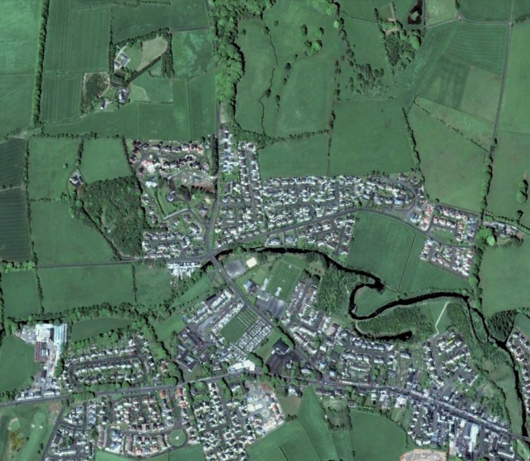
Knockan Rd
Lane
Knowehead Rd
Knowehead Rd
Riverside Walk
Butterfly Walk
Raceview
Mill
Raceview Rd
1
4A
3
2
5A
9
6
7
8
Start point
Finish point
Check point & number
8

