ANNEX B
BROUGHSHANE 10K ROUTE

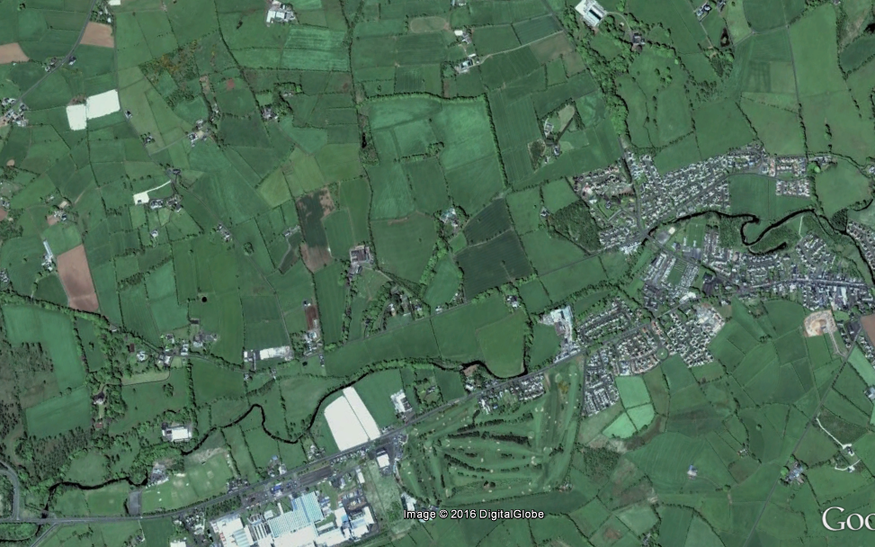
Knockan Rd
Lane
Knowehead Rd
Riverside Walk
Raceview Rd
Ballygarvey Rd
8
6
9
4B
5B
3
2
1
7
Start point
Finish point
Check point & number
4

